Improvisation of ITS technology in VANET

Mahfuzur Rahman  
Department of CSE  
American International University  *Dhaka, Bangladesh*  
mahfuzsrijon0@gmail.com

Nasim Wahid  
Department of CSE  
American International University  *Dhaka, Bangladesh*  
nasimwahid80@gmail.com Shovan Dev  
Department of CSE  
American International University  *Dhaka, Bangladesh*  
shovandev7@gmail.com

Saiful Islam Shuvo  
Department of CSE  
American International University  *Dhaka, Bangladesh*  
saifulshuvo2@gmail.com Wardah Saleh  
Department of CSE  
American International University  *Dhaka, Bangladesh*  
wardahsaleh15@gmail.com

*Abstract*—The total amount of vehicles in the world has experienced a considerable growth, expanding traffic bulk which results in more and more accidents. Intelligent Transportation Systems is one of the solutions to all these problems, which will help to minimize traffic related problems to a great extent and can make our life easier. In this proposed scheme, we are also looking for a smart city frame work where people can lead a safe life on the road. This proposed technology is based on a sensor which can able to manage a decent speed control system. Our improvised technology is also proficient in terms of measuring the distance of an object. This improvised technology also gives focus on a good communication with the driver also by notifying each and every action.

Keywords—vehicles, traffic, improvised, technology, transportation

# Introduction

## Introduction

Accidents are one of the major issues concerning all over the world.. Also, traffic jam is another big issue that makes the lives of the people miserable. **The main traffic**

**problems that we are facing these days are traffic congestion and undetected accidents that occur at the spare time. There are many cases of death reported due to the delay in arrival of ambulance to the hospital at the right time [9].** It is a digital communication system between cars, trucks or between any vehicles and base station and also between any vehicle and RSU (Road Side Unit). Car injury avoidance, secured roads, contamination, and blockage depletion are some of the goals of VANETs [5]. Intelligent Transportation Systems (ITS) narrate technology applied to vehicles as well as base station to carry information between them for better security, efficiency and minimizing traffic blockage [6]. Both vehicle-to-vehicle (V2V) and vehicle-to-roadside (V2R) connections are carried to VANETs to systematically gather traffic reconditions from/to vehicles and roadside units. A real-time algorithm is proposed that makes use of VANET connection abilities to keep away vehicles from traffic connected crowding and also the road incidents. A flow chart is proposed which describes the whole working system that is able to protect us from the road accident and also can reduce the traffic jams.

## What is VANET?

The engrossment in this field of VANET (Vehicular Ad-hoc Network) has dramatically grown up to develop traffic safety and organization on the roads among the research section. VANET is implemented to reduce the accident on the roads and also the traffic for daily life and for gathering the information in the server for safety issues as well [1]. If a vehicle gets some issues or break down suddenly on the road, the whole broadcast information about that vehicle pass through a signal to the other vehicles on a specific range to reduce the accident. **The junctions in a VANET are vehicles and road side units. The activity of these nodes is very fast. Vehicle behaves as transceiver i.e. sending and receiving at the same time while making a highly vital network, which is continuously changing [11].** For this safety issue VANET requirement MAC protocol provides with that services. Recently MAC protocol applies the TDMA techniques and this technique provides with some vehicles to use the same frequency at a time in a specific range. VANET (Vehicular Ad-hoc Network) is a digital network that is deployed to reduce the risk of road accidents and also increase the comfort of passengers by exchanging different kinds of data including traffic conditions, accidents etc. There are three different ways of communication, one is between the vehicles with other vehicles which is stated as inter-vehicle communication. Second one is between the vehicles and the roadside units like antenna, traffic lights etc. which is also known as vehicle-to-roadside communication. The last one is between the roadside traffic lights or antenna etc. which is also known as inter-roadside communication.

## What is ITS?

In this growing world many countries including the ones which are said to be poor countries have started digitalizing very fast. Everybody wants to avoid the hectic situation which is the result of the traffic problems. Transportation is an important concern in every growing city where the Intelligent Transport System (ITS) can come in handy and thus helps to minimize traffic problems. In other words, it helps the people to save time and reach their destinations within the allocated time. For example, students can to go educational institutions on time and emergency patients can be transported to the hospital quickly. ITS helps to get the traffic information for example, the real-timing of the running vehicles and suggests which routes should be used to go faster or with comfort.

## Relationship between VANET and ITS

An advanced protocol introduced on the VANET is the ITS or Intelligent Transportation System. An integrated application is aimed at delivering creative technologies which are related to various modes of transport and traffic control. It also allows the consumers to be more aware and making the use of transport networks smoothly, organized and in an intelligent way. Radio modem connection on UHF and VHF frequencies is usually utilized for the short and extended-range connection within the ITS. RFID (Radio Frequency Identification) and approachable intelligent beacon sensing technologies have developed the technological capabilities that will grant intelligent transport networks globally to benefit from motor safety. Sensing technologies for ITS are worked properly which focus on the vehicles as well as networks.

ITS also includes automatic systems for road safety, such as speed detecting cameras to trace the vehicles running above the permissible speed limit. Electromagnetic loops are placed in each lane of the roads to monitor the speed of the vehicles with the help of radar. Different lanes are allocated separately for cars and buses and in case of violation by either vehicle can easily be monitored by red-light cameras. Bus lanes may also be used for taxis or cars by the concerned body for carpooling in some jurisdictions. Level crossing cameras can easily identify the violating vehicles in case of unlawful crossing of railway intersections. Double white line cameras are also installed to identify the allocated lines of the crossing vehicles. High-occupancy lane cameras can easily detect the vehicles in case of breaching HOV (High Occupancy Vehicle) standards. ITS also assists in linking the urban world via the VANET (Vehicular Ad-hoc Network) in a cutting-edge tech-based traffic structure. Moreover, beyond providing connectivity mobile operators can also play an essential part in these supply chains.

# Literature Review

A systematic Literature review (SLR) creates a remarkable portion in research and execute any all research questions. Intelligent Transport System can be specified as the technology that is appealed to carry foundation like road networks, traffic and transport system [1]. In periods of smart ITS, Vehicular Ad Hoc Network (VANET) is an immense automation which can allow security and consolation for the passengers. A new dynamic and revolution in our country by the introduction of automated vehicle and effortless traffic technology is the main motive. Nowadays, our country is facing a tremendous amount of loss due to road accidents. Also, traffic jam is another big issue that made peoples live miserable. Our preferred work offers expending and unconventional assistance that will develop the traffic treatment in the future. Our intent is to decreasing risk of latent incidents as there has been a scaring rise in road accidents. People can lead a hassle-free and a safe life through this scheme. There are already exists various journals with various schemes on these two topics (Road Safety & Traffic Jams) but individually where our proposed method represents the solution for both the topics. Also, most of the previous works was based on Vehicle-to-Vehicle (V2V) style but collusion cannot happen only for vehicle, so this scheme is proposed on Object-to-Object (O2O) format where these updates are making our stratagem more acceptable.

The Sensors and the Innards

Ultrasonic Sensor

An ultrasonic sensor is an electronic tool which finds out the distance of a target object and modify the reflected sound into an electrical signal with the help of passing on ultrasonic sound waves. It’s to be noted that ultrasonic sounds fly faster than the audible speed of sound (i.e. the sound that humans can hear). There are two main components of ultrasonic sensors - the Transmitter Radio which uses piezoelectric crystals to emit sound. Second component is The sensor which computes the time it takes between the transmitters sound release and its interconnection. The sensor computes the time it takes between the transmitter's sound release and its interconnection with the receiver in order to resolve the distance between the sensor and the object. The formula for this calculation is D = ½ T x C (where D is the distance, T is the time, and C is the speed of sound ~ 343 meters/second).

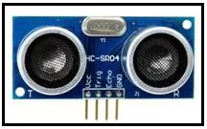

Figure 1: Ultrasonic Sensor

Ultrasonic sensors are used primarily as proximity sensors. They can be used in self-parking vehicle technologies and protective anti-collision technologies. As well as industrial technology, ultrasonic sensors are also used in robotic obstacle detection systems. Ultrasonic sensors are not as sensitive to interference from smoke, gas and other airborne contaminants when opposed to infrared (IR) sensors in proximity sensing applications (though the physical components are still affected by variables such as heat). Ultrasonic sensors are often used as level sensors in closed containers to track, control and regulate liquid temperatures (such as vats in chemical factories). Most importantly, the medical industry has been able to generate photographs of internal organs, recognize cancers, and ensure the health of babies in the womb through ultrasonic technology.

Road Side Tower

The Road Side Towers has a vital role in this proposed work. It basically works as a outside informer. In this proposal, we are using all the Mobile Networks as our Road Side Tower because the Mobile Network Towers are already built up in everywhere of the country, also on a specific distance from one another. And we also need something like these in our proposed method thus we can connect them with our main sensor to get all the information and release those among us.

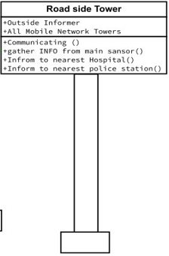

Figure 2: Road Side Tower Class diagram

The Towers will connect with one another and also with the main sensor, thus they can be able to get the information from the sensor connected with the object and also can able to transfer the signal. The towers will be able to connect with the nearest hospital and police station, so that it can inform the hospital and police station if something wrong will happen. The Towers are able to connect with those are situated in its range. So, Road Side Tower is playing a useful and vital role in this proposed work for our safety.

## The Main Sensor

This proposed work has its main element and that is the Main Sensor which basically works as a controller. It controls all the conditions and the performance of an object, thus the object can be indirectly control by the sensor. The sensor is the core of our proposed system. The whole working system and connectivity are depending on this sensor and this is the reason to named it the main sensor. The sensor connects with both Ultrasonic sensor and Road Side Tower. Sensor take signals and information from these two parts and perform the task.

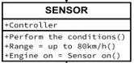

Figure 3: Main Sensor Class diagram

This Main Sensor has some unique and important rules and configuration. The sensor will active when the corresponding device will on or for any vehicle the engine will be on. The Sensor has some limitations like it has a range that up to 80 km/hour. That means if the sensor is on then the speed of the vehicle cannot cross 80km/hour. The sensor also has some conditions to work. It basically has four different conditions(D>10m, D=6m-10m, D<=5m, D<=1.5m) and those conditions are totally depending on the distance between two objects. If any object detects by the Ultrasonic Sensor then the signal will pass to the main sensor. The sensor then acts which is depending on the information that take from the ultrasonic. There is more minor controlling function which are also control by the main sensor like buzzer on, indicator on/off, changing the lane of road according to the conditions. And also, one of the most main function of this sensor is controlling the speed and decrease when needed like (speed = current speed/2 or current speed/ 4).

## Proposed work

This whole method is proposed for our safety on road. Nowadays, road accident and traffic jams are very common for us. So, for secure our lives we have to take actions. This is one of them. A method is proposed for the safety purpose of our daily travelling life. In this proposed work, there are three component which are playing a vital role to complete the whole task. And those are the Main Sensor, the Ultrasonic Sensor and the Road Side Tower. These three portions are connected internally with one another and pass the information and perform their own tasks. The ultrasonic sensor is using for the detection in this work. It can detect any object or any vehicles or human. So, when it detects human, vehicles or any object in a specific range then it will inform or pass a signal to the main sensor. And, from here the work of the main sensor has begun. And, the main sensor works with some limitations and conditions. First of all, it will check the distance between V2V (vehicle to vehicle) or O2O (object to object). If the distance is greater than 10 meters (D > 10m) then the vehicle will continue with the same or current speed. Else if the distance is between 6 meters to 10 meters (6m<=D<=10m) then the indicator will on immediately and the speed of the vehicle will become half of the current speed (speed= current speed/2). If the sensor cannot find these two conditions then it will go for another condition that if the distance is less than equal to 5 meters (D <=5m) then the buzzer will on to notify the driver to decrease the speed. After that it will wait for 5 seconds for any action from the driver but if no action will be taken from the driver then after 5 seconds the vehicle will change the lane automatically and will going to check the conditions from the beginning. If the lane can’t be changed then the sensor will check if the distance is less than equal to 1.5 meters (D<=1.5m) then the sensor will take an action on the speed again and the speed will become one fourth of the current speed (speed= current speed/4) and the indicators will on for the other vehicles. This main sensor will also connect with the road side tower which work is to collect the data of the road situations in a specific range and to inform the nearest hospital and police station if something wrong will occur. All of these actions and conditions will work when the sensor will on and the sensor will on immediately when the engine of the vehicle will on. And when the sensor will active, the vehicle has a limitation of speed that is up to 80km/hour. As the proposed work is about O2O (object to object) style detection, the system will work slightly different for humans who will use the system through their mobile or smart watch. Then there will be no speed limitations for the mobile or smart watch users. The system will work and detect directly in a specific range and notify the user through buzzer or vibration. So, by doing all these, the system will work for our safety.

## Flow Chart

This is the proposed work which is presented as in a flowchart. This flow chart describes how the whole system works and when the main sensor performs the conditions and also communicate with both ultrasonic sensor and the road side tower.

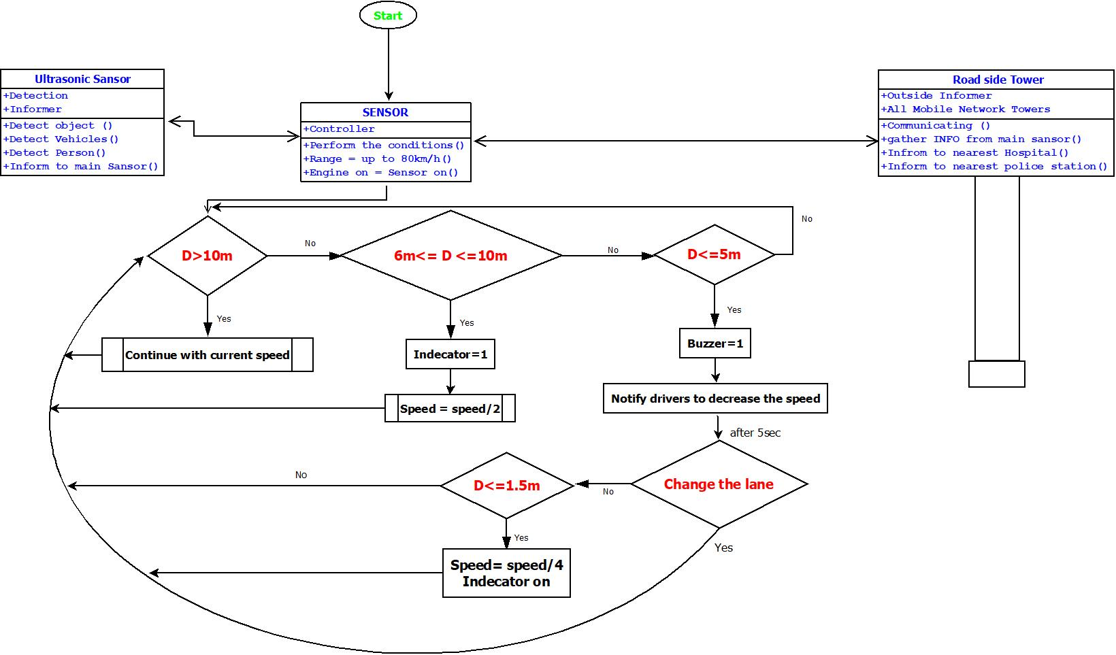

Figure 4: Flow Chart

# Analysis

Every research work will get popularity when it can able to introduce with new scheme. To go through the whole paper, it can be spontaneously prescribed that if we work on the implementation of our research, it will bring another revolution on our transportation system. Our proposed technology is based on a sensor which can able to manage a decent speed control system. Our improvised technology is also proficient in terms of measuring the distance of an object. This technology is so much potential that it performs any action with the vehicle engine directly if the controller of the vehicle isn’t obeying all the rules and regulation have been made for this.

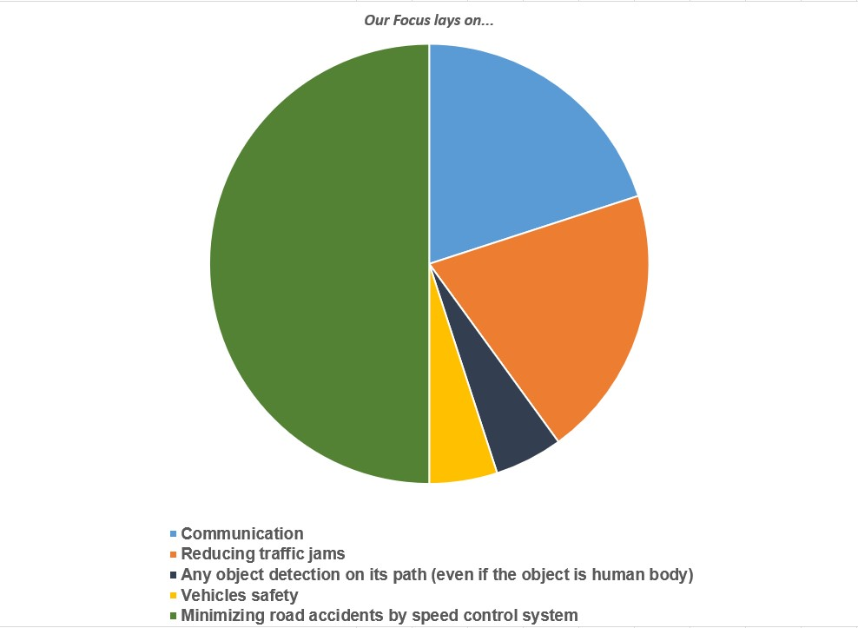

Figure 5: Graph of Analysis

This improvised technology also gives focus on a good communication with the driver also by notifying each and every action. It is capable of minimizing the risk of collisions and also traffic jam. Eventually after connecting all the analytical standard, it can be said that this technology can have a much better effect.

# comparison

One more time we are ensuring that our improvisation technology is the best of all the related previous work in this field. It can be understood through a comparison between all the previous work and our proposed work. Most of the previous works are formed of vehicle to vehicle style but the main thing is a collision is not just for the vehicle, any type of object can cause for a collision. In contrast, we change the

style of object to object for our working principle. In

previous work there might be used Intelligent Traffic Lights as Roadside Tower. On the contrary, we used Mobile network Towers as Roadside tower which is smarter and faster technology than ITLs. Even though There came out many different solutions from that previous works like using signal control, Intelligent Traffic Lights (ITLs), routing protocol etc. Our intention is composing a different type of solution through using ultrasonic sensor (which can measure the distance of an object) and ITS sensor (to control the speed of a vehicle) The working principle of both two combined sensor is described on the flowchart. Whereas our motive stands both on reducing traffic jams and also on public safety.

Our proposed work is the bundle of all kind of support of road safety of a vehicle and our lives. It consists of speed control system from automated vehicle if the driver isn't aware, the roadside tower where the vehicle can communicate directly from the nearest tower, it also provides safety for the vehicle from robberies etc. Following the graph, the audience can able to get a proper knowledge about our proposed work.

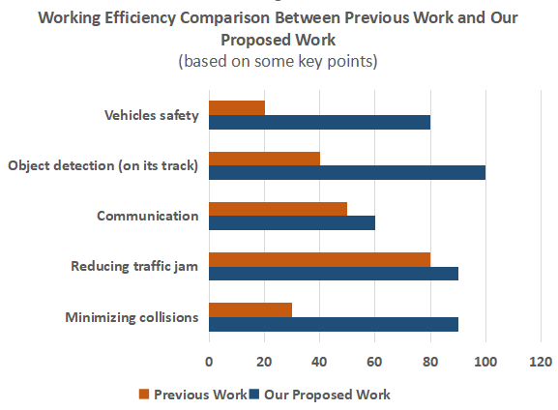

Figure 6: Graph of Comparison

# Conclusion

Nowadays in the world, road accidents and traffic problems are one of the major issues for the people. So VANET is the giving the solution for these two major reasons along with many other various reasons as well. Users require safety on road in future. **The objective is to increase the driver safety and comfort by relaying required information about the context from one vehicle to another.** VANET applications is the proper way to reduce the future accidents and also the traffics. So, it must be implanted using trusted computing-based solution to promote trust among road users and their vehicles and infrastructure. a systematic and effective approach was represented to manage the traffic and road accident issues. Different works about ITS are compared. The key idea is to create a smart city framework for VANET by this proposed work which Consists a smart and safe transport system.

# Future work

First of all, with the advancement of technology and the sudden increase in the number of smart vehicles, the introduction of this proposed work is necessary; typical VANETs face many technological difficulties in deployment and management due to less flexibility, measurability, insufficient connection and deficient intelligence. Cloud computing is considered a way for VANETs to meet these criteria. Next-generation VANETs, however, may have unusual statements for high-mobility autonomous vehicles, low latency, real-time applications and networking, which traditional cloud computing does not fix. The integration of fog computing with the traditional cloud for VANETs is also addressed in current and future VANETs as a theoretical solution to many problems. In addition, by integrating Software-Defined Network (SDN), which offers constancy, programmability, and global network perception, fog calculating can be improved. In potential VANETs focused on fog and a mixture of fog and SDN, we offer two sample scenarios for timely transmission of safety messages.

## Figures

1. Ultrasonic Sensor
2. Road Side Tower Class diagram and Image
3. Main Sensor Class diagram
4. Flowchart
5. Graph of Analysis
6. Pie chart for Comparison

##### Acknowledgment

First of all, we would like to thank the Almighty, for His grace in accomplishing our project thesis report timely. We would like to express our gratitude to the Faculty of Science & Information Technology to keep thesis credit in the curriculum of the graduation program and give me a scope of tasting the flavor of industry-oriented tasks and the field of work with my interest. We are also grateful to the Faculty of Science & Technology & Office of Placement & Alumni, AIUB to arrange an opportunity for choosing an own interested organization and complete a thesis there. We are also thankful to our thesis supervisor Wardah Saleh, Lecturer, Department of Computer Science from the core of my heart for her kind support, guidance, constructive, supervision, instructions, and advice and for motivating me to do our thesis smoothly. We feel proud and gratified that we were always held the under supervision of the timely meetings arranged by her. Moreover, to prepare this report and other documentation regarding the thesis report and else we would show appreciation to all the resources and guidance that were required to complete the report successfully.

##### References

1. Ganesh Khekare, Apeksha Sakhare, Department of Computer Science and Engineering, G. H. Raisoni College of Engineering, “A Smart City Framework for Intelligent Traffic System Using VANET”, Conference Paper · March 2013
2. 2.Mohammed Saad Talib, Aslinda Hassan, Burairah Hussin, Ali Abdul-Jabbar Mohammed, Ali Abdulhussian Hassan, Ammar Awad Mutlag, Faculty of Information and Communication Technology, Universiti Teknikal Malaysia Melaka (UTeM) - Malaysia College of Administration and Economics, University of Babylon – Iraq, Faculty of Information and Communication Technology, Universiti Teknikal Malaysia Melaka (UTeM) - Malaysia, Faculty of Information and Communication Technology, Universiti Teknikal Malaysia Melaka (UTeM) – Malaysia, “Vehicular Ad hoc Network for Intelligent Transport System: A review”, International Journal of Engineering & Technology, 7 (4.36) (2018) 350-353
3. A.FITAH, A.BADRI, M.MOUGHIT, A.SAHEL, EEA & TI Laboratory Faculty of Sciences and Techniques of Mohammedia (FSTM), Hassan II University of Casablanca, BP 146, Mohammedia, “Performance of DSRC and WIFI for Intelligent Transport Systems in VANET”, Procedia Computer Science 127 (2018) 360–368
4. 4.Sandhaya Kohli, Bandanjot Kaur, Sabina Bindra, Dept. of CSE, RIMT-IMT, Dept. of CSE, RIMT-IET, “A comparative study of Routing Protocols in VANET”
5. 5.Ganesh S. Khekare, Apeksha V. Sakhare, Department of Computer Science and Engineering, G. H. Raisoni College of Engineering, “Intelligent Traffic System for VANET: A Survey”, International Journal of Advanced Computer Research (ISSN (print): 2249-7277 ISSN (online): 2277-7970) Volume-2 Number-4 Issue-6 December-2012
6. 6.Pallavi A. Targe, M. P. Satone, PhD, PG Student, Department of E&TC, K. K. Wagh Institute of Engineering Education, Professor, Department of E&TC, “VANET based Real-Time Intelligent Transportation System”, International Journal of Computer Applications (0975 – 8887), Volume 145 – No.4, July 2016
7. 7.Channakeshava RN, Dr, Meenatchi Sundaram. IMPROVISATION OF SIGNAL QUALITY IN CELLULAR IOT IN VANET. JCR. 2020; 7(14): 1460-1463. doi:10.31838/jcr.07.14.330
8. 8.Y.A.Dahou Djilali1, Y.Bakhti1, B.Kouninef1, B.Senouci2, “Performances Evaluation study of VANET Communication Technologies for Smart and Autonomous Vehicles”, Conference Paper · July 2018.
9. K Athavan. Automatic Ambulance Rescue System.Second International Conference on Advanced Computing & Communication Technologies 2012.p.190-5.
10. S Cai, M. Becherif, M Bakhouya, M Wack.A Context Aware Embedded System for Intelligent Vehicles and Smart Roads Proc. of ICPS, UPC Workshop2010.
11. V.D. Khairnar, S.N. Pradhan Comparative Study of Simulation for Vehicular Ad-hoc Network International Journal of Computer Application, 4 (2010), pp. 15-18